**an Todo d Blog Application**

In this assignemnt-based project, I have implemented a session based Todo and Blog application using PDO's approch.

**Salient Features**

Session based Todo App implemention.

Blog App using PDO.

Session based authentication mechanism.

Only logged in users can post new blogs.

Read blog page is set public.

Using given below credentials, one can post blog using local server, email me at csmdot84@gmail.com to get list of users of live server.

$users = array( array("user" => "user1@blog.com", "pass" => "pass1", "name" => "John") array("user" => "user2@blog.com", "pass" => "pass2", "name" => "Vein") array("user" => "user3@blog.com", "pass" => "pass3", "name" => "Potter );

# How to setup and run the code

Clone this repo using git clone https://github.com/rajBinMoti/web-assignemnt-8thsem in htdoc. There is a file [dbSetup.php](https://github.com/rajBinMoti/web-assignemnt-8th-sem/blob/main/dbSetup.php) in root directory, which will generate a dummy database with some record to test the blog side of application. Run it on localhost using [http://localhost/todo&blog-app/dbSetup.php](http://localhost/todo%26blog-app/dbSetup.php) url.

# How to run the application

Open browser and visit [http://localhost/todo&blog-app](http://localhost/todo%26blog-app) and test it on local server. [One copy of this code is also deployed on live server at https://todoblog.000webhostapp.com/](https://todo-blog.000webhostapp.com/)

**Odds**

Some logical

fi

xes are still pending to do...will

fi

x soon.

**Screenshots**

Navbar when there is a guest user.



Navbar when there is a logged-in user.



On home page there display components of Todo and Read blog are imported from [components.php](https://github.com/rajBinMoti/web-assignemnt-8th-sem/blob/main/components.php) and these same components are used in [todo.php](https://github.com/rajBinMoti/web-assignemnt-8th-sem/blob/main/todo.php) and [blog.php](https://github.com/rajBinMoti/web-assignemnt-8th-sem/blob/main/blog.php), respectively.

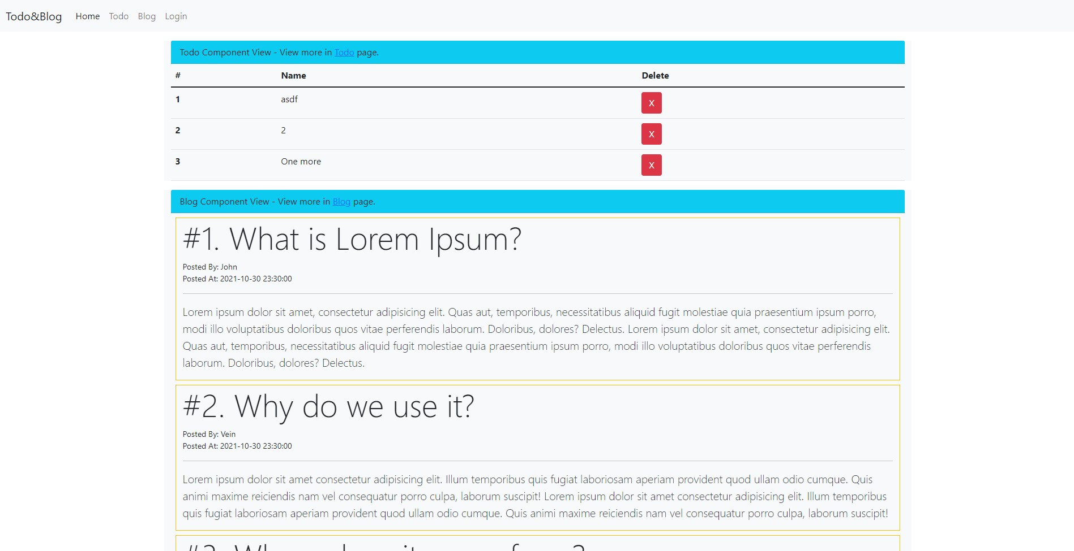

[**README.m**](https://github.com/rajBinMoti/web-assignemnt-8th-sem/blob/main/imgs/home-page.png)

[**d**](https://github.com/rajBinMoti/web-assignemnt-8th-sem/blob/main/imgs/home-page.png)

On [Todo Page](https://github.com/rajBinMoti/web-assignemnt-8th-sem/blob/main/todo.php) there is a add task component with display Todo component.

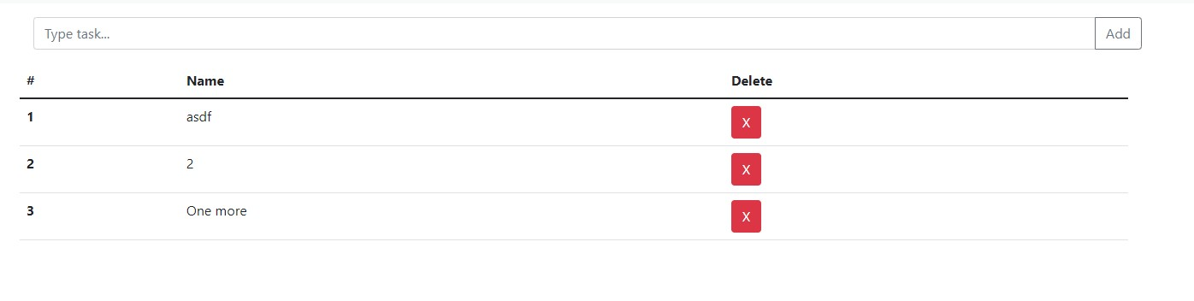

[**PH**](https://github.com/rajBinMoti/web-assignemnt-8th-sem/search?l=php)

[**P**](https://github.com/rajBinMoti/web-assignemnt-8th-sem/search?l=php)

[100.0](https://github.com/rajBinMoti/web-assignemnt-8th-sem/search?l=php)

[%](https://github.com/rajBinMoti/web-assignemnt-8th-sem/search?l=php)